INTRODUCTION:-
A compression test is a method for determining the behavior of materials under a compressive load. Compression tests are conducted by loading the test specimen between two plates and then applying a force to the specimen by moving the crossheads together. The compression test is used to determine elastic limit, proportionality limit, yield point, yield strength and compressive strength.
Compressive Strength :- It is the maximum compressive stress that a material is capable of withstanding without fracture. Brittle materials fracture during testing and have a definite compressive strength values. The compressive strength of ductile materials is determined by their degree of distortion during testing.
OBJECTIVE:-
To determine the compressive strength of given sample.
APPARATUS:-
Universal compressive testing machine (UTM), Vernier calipers, stop watch, dial gauge.
THEORY:-
Structure components such as columns and struts are subjected to compressive load in applications. These components are made of high compressive strength materials. Not all the materials are strong in compression. Several materials, which are good in tension are poor in compression. Many materials poor in tension are good in compression. Cast iron is one such example. This strength is determined by conducting a compression test. During the test, the specimen is compressed and deformation Vs. the applied is recorded.
Compression test is just opposite in nature to tensile test. Nature of deformation and fracture is quite different from that in tensile test. Compressive load tends to squeeze the specimen. Brittle materials are generally weak in tension but strong in compression. Hence this test is normally performed on cast iron, cement concrete etc. But ductile materials like Aluminium and mild steel which are strong in tension are also tested in compression.

Formulae :
Youngs modulus = slope of stress Vs Strain.
Ultimate compressive strength = Force (N) just before rupture / (original c/s area)
Percentage reduction in length = (initial length- final length)*100/initial length.
PROCEDURE :
- Dimensions of test piece is measured at 3 different places along its height/length to determine the average c/s area.
- Ends of the specimen should be plane. For that the ends are tested on a bearing plate.\
- The specimen is placed centrally between the two compression plates, such that the center of moving head is vertically above the center of specimen.
- Load is applied on the specimen by moving the movable head.
- The load and the corresponding contraction are measured at different intervals. The load interval may be as 500kg.
- Load is applied until the specimen fails.

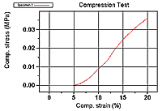

OBSERVATION:
- Initial length or height of specimen h =______mm.
- Initial dia of specimen d₀ =_____mm.

sl.no | Applied load (P)in Newton | Recorded change in length(mm)
CALCULATION:
· Original cross-section area A_{o} = _____mm²
· Final cross-section area A_{f} = ____mm²
· Stress = ____N/mm²
· Strain = ____
For compression test, we can
· Draw stress-strain (a-s) curve in compression,
· Determine Young’s modulus in compression,
· Determine ultimate (max.) compressive strength, and
· Determine percentage reduction in length (or height) to the specimen.
PRECAUTIONS:
· The specimen should be prepared in proper dimensions.
· The specimen should be properly to get between the compression plates.
· Take reading carefully.
· After failed specimen stop to m/c.
RESULT:
The compressive strength of given specimen =——————- N/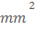
CONCLUSION:

DISCUSSION:
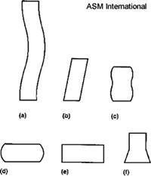
Fig2: Modes of deformation in compression testing
VIVA-QUESTIONS:
- Compression tests are generally performed on brittles materials-why?
- Which will have a higher strength: a small specimen or a full size member made of the same material?
- What is column action? How does the h/d ratio of specimen affect the test result?
- How do ductile and brittle materials differ in their behavior in compression test?
- What are bi-modulus materials? Give examples.
- In cylindrical specimen, it is essential to keep h/d < --- to avoid lateral instability due to bucking action.

COMPRESSION TEST ON WOOD

INTRODUCTION:

In this experiment, three types of wood will be tested to failure in compression. Several material properties will be determined for each specimen.

Wood consists of tube-like cells which are tightly cemented together to form a basically homogeneous material. The cells, which mostly run in the same
direction, form fibers, which constitute the grain. Important physical properties are moisture content and density.

Factors that affect the properties of wood include the arrangement of the grain and the amount of heartwood (the dark core wood of the tree). Irregularities also affect material properties. There are three important classes of defects: 1.) knots, 2.) checks, and 3.) shakes. Knots are the areas of the trunk in which the wood surrounds the base of the branch as the tree grows. Checks are longitudinal
cracks that run normal to the growth rings and shakes are cracks that run parallel to the growth rings.
Wood is anisotropic which means that properties will be different in different directions. When wood is loaded in compression parallel to the grain direction,
it will resist large forces. However, if it is loaded transverse to the grain direction it can be quite weak. Wood, when loaded in compression parallel to its
grain, is one of the strongest structural materials in proportion to its weight. Wood is relatively weak in shear parallel to the grain, and will often fail in this mode.

OBJECTIVES:

To conduct a compression test on three types of wood and obtain material properties for the tested samples.

THEORY:

Figure 1 illustrates the test specimen under compression loading.
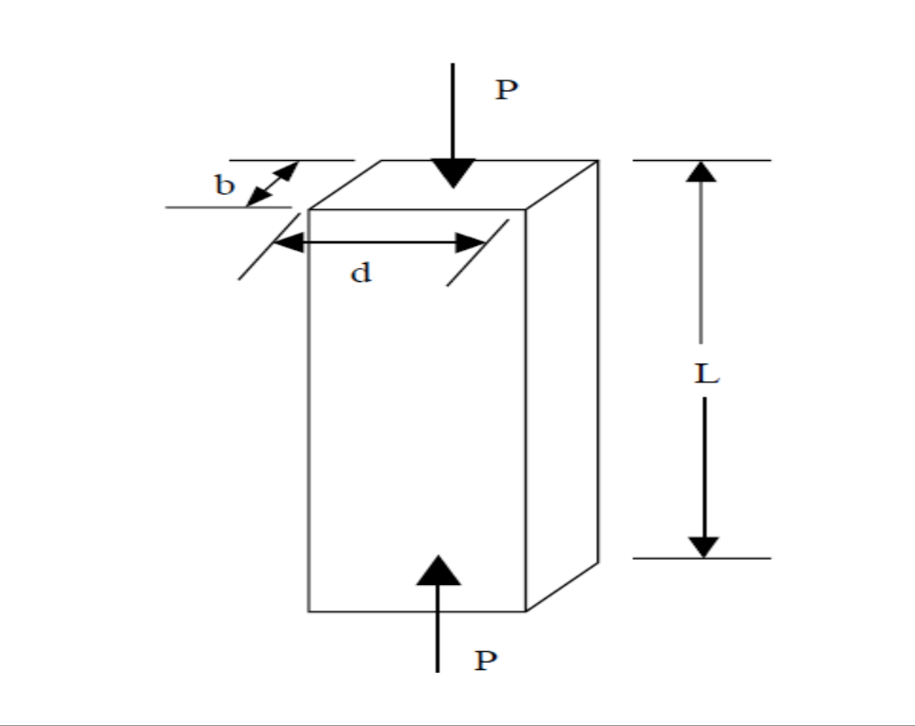
Fig 1: wood under compressive load

The test consists of uniaxial loading, and therefore the stress is calculated by:
⬧ = P/A
Where: P is the applied load
A is the cross-sectional area
MATERIALS TO BE TESTED:

Three types of wood will be tested; red oak, yellow birch, and ponderosa pine. Specimens have been precut into blocks of approximately 1-3/4" x 1-3/4" x 8". Exact measurements must be made for each specimen prior to testing.
EQUIPMENT TO BE USED:

MTS Testing Machine 55,000-lb capacity

PROCEDURE:

Test preparations:
The weight, length, and cross-sectional dimensions of each specimen must be measured prior to testing.

Test data:
Apply an increasing load on the test specimen parallel to its longer axis. Note down the change in length for every load applied. Produce a stress-versus strain diagram for each of the three tests, similar to the one shown in Figure 2 Note that the load versus stroke curve may not contain an initial straight-line portion. If not, you will need to estimate the best fit tangent to the curve to obtain the Modulus of Elasticity, E. In doing this you may find that the tangent line intercepts the horizontal axis to the left of the curve. If this is the case, the point where the tangent line intercepts the horizontal axis should be selected as the location for the origin.

Fig.2
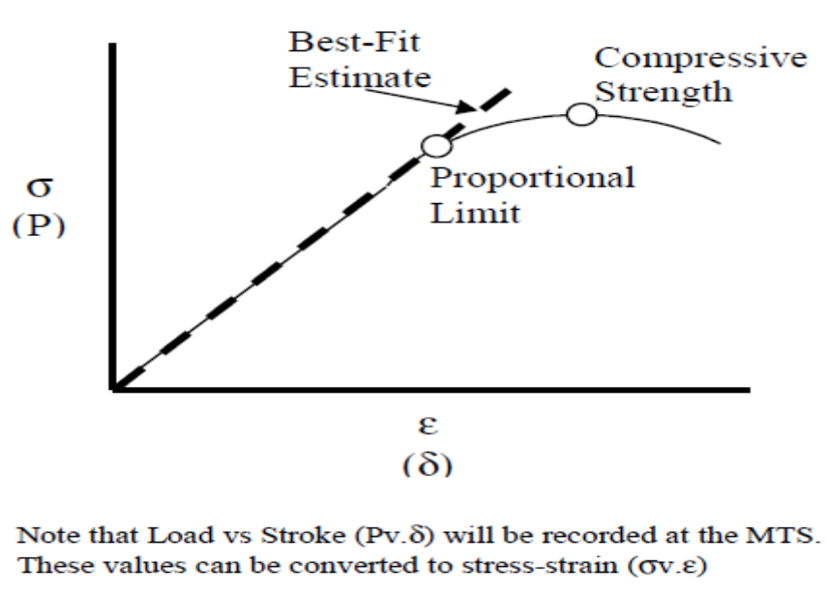

Proportion limit=stress at the point where curve deviates fom the straight line portion of stress vs strain graph

Formulae:
E(modulus of elasticity) = σ/ε
σ_{c} (compressive strength) = Pmax/A
REPORT REQUIREMENTS (RESULTS):

(1) Stress versus strain plots from MTS data file complete with:
Curve fitting to obtain Tangent Modulus.

(2) Determine the following properties for each specimen:
a. Proportional Limit, σpl
b. Compressive Strength, σ_{c}
c. Modulus of Elasticity, E

(3) Discuss sources of error as well as their impact on the design process.
(4) Describe the types of failure observed for each specimen with sketches of the failures.

QUESTIONS:

(1) Are the compressive strength and the specific gravity related? If so, what trends do the data indicate.
(2) Strain calculations based on the measured stroke may not be very accurate when premature crushing occurs at the ends of the specimens. Discuss how this would effect the experimental values determined.

PART – 2

ANIMATION STEPS

PART – 3
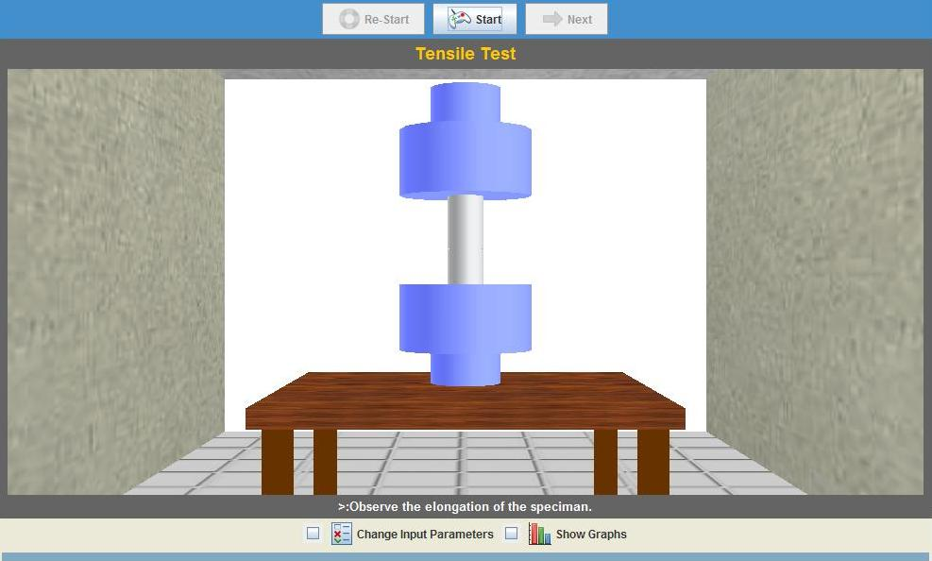
VIRTUAL LAB FRAME

